Manual for running the ThreeME model for results in paper “Mitigating Foreign Fossil Fuel Shocks: The Role of Renewable Energy and Industrial Electrification in the Netherlands”
Preparation
- Download Eviews, and make sure that you have a license.
- Make sure you have a github account and take the model from
  - https://github.com/ThreeME-org/ThreeME_V3-open
  - Branch: FRA-DDIVIDEND-OFCEWP2024
  - More information on using the model – besides this document – is given under the folder ‘doc’.
- Make sure that Eviews knows your working directory
  - Open Eviews, go to options in the taskmenu, click on general options. Go to ‘file locations’, and make sure that the model knows where to find the model (“current data path”)
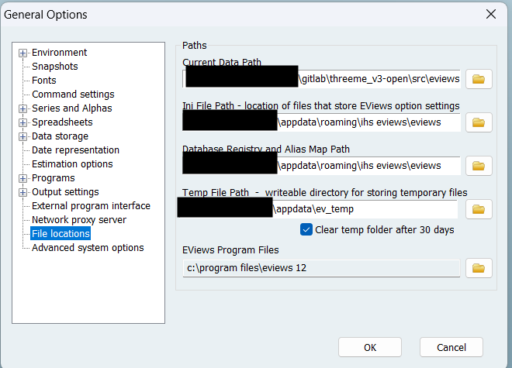
Run the model
- Open software program Eviews.
- Open file scr/Eviews/main.prg, via File à open à Programs.
- Run this file. (Press run in the upper left corner.)
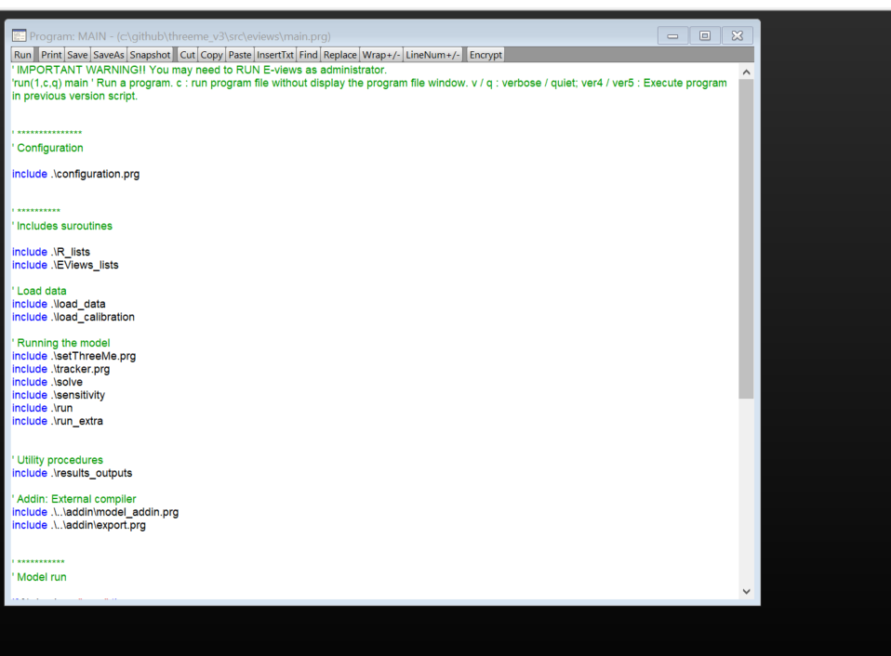

This creates a new workfile with the data of the model and an Excel file (sensitivity.xlsx) in the folder “Results”

Creating figures and charts
In the folder "Results" you will also find the file Results_withdistribution_charts.xlsx.
This file will automatically create the results in figures and charts when you copy and paste the “Raw” sheet (from sensitivity.xlsx) to the “Raw” sheet of this file.

